Contents
Preface Page 3
Botanie 6
Habitat of Cocaplants 11
Cocaleafs and Health 13
The value of a Cocaplant 15
Buying Cocasseds 20
Growing and conservation of Cocaseeds 17
Growing Cocaplants from seeds 18
Transplanting Cocaplants 19
Soil for Cocaplants 21
Fertilizers 22
About watering 25
Diseases and plagues 26
Growing outside 27
Growing in greenhouse 29
Growing lights 31
Cocagrowing in livingroom 33
Growing under Mercury-Iodine lights 34
Harvest and drying of cocaleafs 35
Rum & Coca 36
Coca Tea 38
Misunderstandings about Coca 40
The persecution of the Cocaplant 41

Preface
By increasing tourism to Latin America, many people have experienced the stimulating and healing effects of the Coca plant. It is obvious that some of these people want to posses such a miraculous plant. Many attempts were made to grow a Coca plant indoors, but just a few succeeded. Only some universities with experienced botanists were capable to cultivate Coca plants. None of this knowledge has ever been published.
However, the number of people that are successfully growing a Coca plant with much joy and satisfaction is increasing.
Within the pages of this book the reader will find information pertaining to the home cultivation of the Coca plant and other related topics. A Coca plant can live for about 60 years, and in all this time she will please you with her beautiful appearance and provide an abundance of tasty and healthful leaves.
Happy Growing!
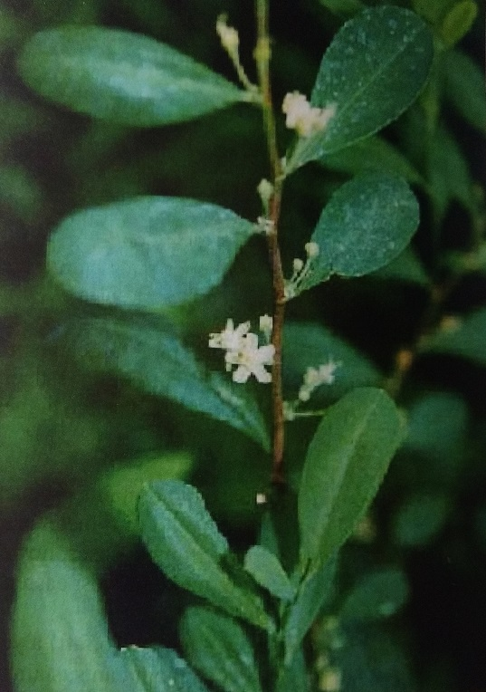

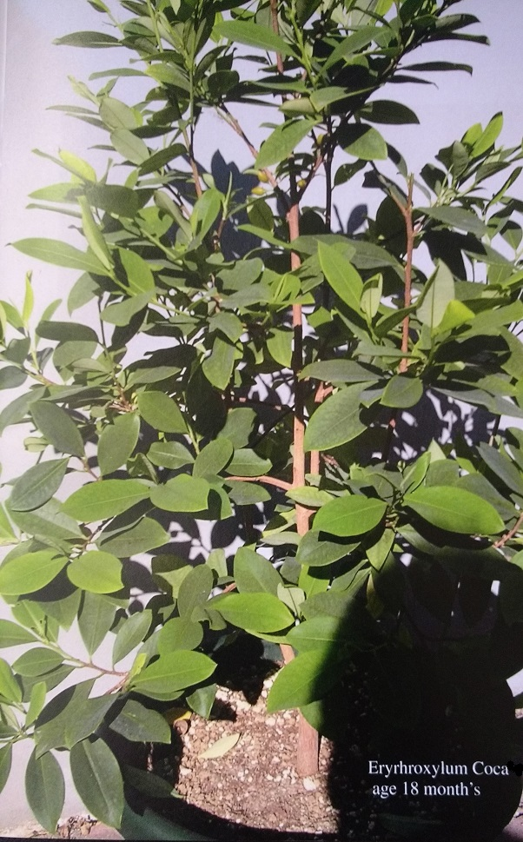
Botanie
The Coca plant belongs the family of Erythroylacea, wich contains about 200 separate species.
The most well known species are:
Erythroxylum coca var. Coca Bolivia, Peru, Ecuador
Erythroxylum novogranatense Columbia
Erythroxylum truxillensis The coca plant belongs to the family of Erythroxylacease wich Desert oasis Peru
These four species are the most important for cocaine production. Erythroxylum coca var. Coca has the highest contents of cocaine. Erythroxylum truxillensis has the highest content of total alkaloids.
A coca plant can live up to 60 years and reamins productive for all these years. She can reach a height of 6 meters (~20 ft) and a width of 9 meters (~30 ft). In most cases, however, she will be cut to a man´s height to make haverst easier.
A branch of coca plant can grow 2 meters (~6.5 ft) a year.
Under the right circumstances a coca plant can sustain abundant growth and develop numerous branches and leaves.

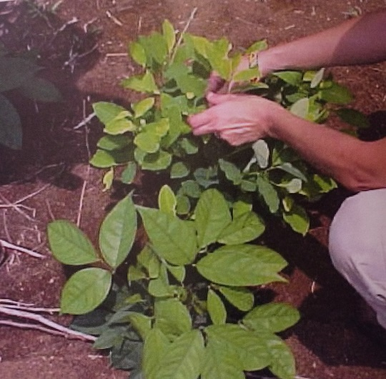

Erythroxylum Truxillensis: With new leafs and twigs grown after she has been pruned

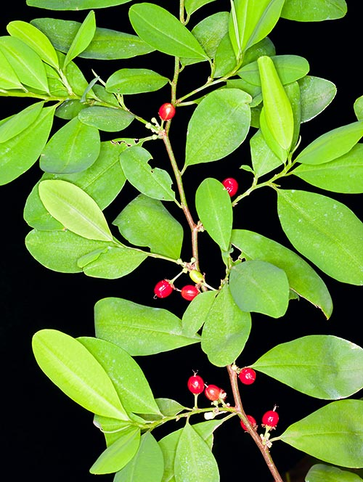

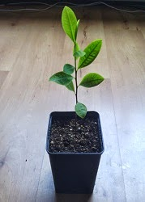

Habitat of coca plant

Erythroxylum coca grows on the moist, warm slopes of the eastern Andes at an altitude of 1000 to 2500 meters (3280 to 82300 ft). The temperature can vary between 0° to 45° Celsius (32° to 113° Fahrenheit), but predominantly stays in the optimum range of 15° to 30° C (59° to 86° F). Temperatures under 0°C are deadly for coca plants; however, older plants can withstand a minor amount of frost for a few hours.
Plants at higher altitudes often contain more alkaloids than those at lower altitudes. This is not related to differences in air pressure, as is often assumed, but to a better climate in general; perpetuating this misconception is the frequent confusion of the less potent lowland Erythroxylum Ipadua with Erythroxylum coca. Plants growing at sea level, under the right conditions, can contain as many alkaloids as those at higher altitudes.
Some plants receive abundant rain year-round, while others get only four months of rain; Deep rooting allows the plants to survive eight months of drought. The coca plant loves water but hates to stand in soaked soil. She grows well on steep mountain slopes where water runs off easily. Though very adaptable to different climates, the coca plant will grow best in a more stable environment with similar day and night temperatures.
The ideal climate for a coca plant:
Temperature: 15° to 30° C (59° to 86°F)
Humidity: 30% to 70%

The Erythroxylum Truxillensis is the rarest of all the coca plants. It grows in the desert oasis on the west coast of Peru at an altitude of 100 to 500 meters (328 to 1640 ft). An arctic sea current cools the climate to an average of 24°C (75°F) during the day and 17°C (63°F) at night. It only rains once every few years, but oasis springs provide the plants with sufficient water; distinctively aromatic plants of the finest quality grow in this fertile land. The Coca-Cola Company uses these leaves for flavoring their famous beverage.

Coca leaf and health
For 8000 years the coca leaf has been highly valued for its healing and stimulating properties. It is a very important source of protein, vitamins, and minerals for the Highland population of the Andes. The coca plant is one of the most nutritious plants in the world; it contains more calcium than milk and more protein than meat. It can withstand comparison to all fruits and vegetables. Coca leaves are consumed by chewing, drinking as a tea, or drinking as an alcoholic beverage containing coca laef extract (tonicum).
Studies by various univerisities have shown that consumption of coca leaves is not hazardous to your health, nor is it addictive; on the contrary, the leaves are a valuable source of nutrients necessary to keep your healthy. Consuming coca leaves on a regular basis protects against cardiovascular diseases, colon cancer, and tooth decay.
Medicinally, the coca plant is used to treat altitude sickness, depression, obesity, high blood pressure, asthmatic bronchitis, diabetes, and stomach and colon problems. In the western world, the coca plant has a bad reputation because of the drug cocaine; one can hardly imagine that a plant containing this drug can be benefial to consume. However, one must simply learn more about the plant in order to understand it.
Apart from cocaine, coca leaves contain many types of alkaloids wich each have their own properties. These alkaloids work synergistically. In other words, they reinforce each other; this is why only a few grams of coca leaves can already produce effects.
By consuming 2 g of coca leaves with an alkaloid content of 1.25% you get about 25 mg (0.025 g) of alkaloids such as cocaine, ecgonine, hygrine, etc. This quanntity is enough for pleasant sensations; you will feel bright, stimulated, and relaxed for about 4 hours. Other than alkaloids, coca leaves contain protein, vitamins, and minerals. They are also rich in flavonoids, or polyphenol antioxidants wich support energy processes in the body and help defend it against disease. You will be stimulated in a mild and pleasant way without damaging your halth.
Cocaine (cocaine hydrochloride) is a chemical derivate of the coca plant wich is extensively chemically treated and lacks any comparison with the healthy coca leaf.
Nutritional value of coca leaves (100 g):
Proteins: 19.9 g…………………………………….. B1: 0.8 mg
Phosphorous: 405 mg………………………….. B3: 1.7 mg
Potassium: 1110 mg……………………………. B6: 0.8 mg
Calcium: 2191 mg………………………………... E:53 mg
H (Biotin): 0.5 mg…………………………………. C: 2 mg
Magnesium: 911 mg…………………………….. Iron: 36 mg
Zinc: 4 mg…………………………………………….. Boron: 24 mg
Nicotinic acid (Niacin): …………………………. 5 mg
Vitamin A as Beta-Carotene: ………………… 16.6 mg
Alkaloids are organic nitrogen-based compounds that are produced by many plants. They form an energy reserve in the metabolic processes of the plant. Alkaloids help plants defend against insects and diseases. The chemical stucture of alkaloids resembles proxeronine, wich is also produced by plants in very small amounts. Some plants metabolize their surplus of proxeronine into alkaloids, and eventually reverse the process again if necesary. Proxeronine is important for the human metabolism as well and is quickly absorbed into the body. The resemblance of alkaloids to proxeronine explains its similarly hasty rate of absorption. Familiar alkaloids include caffeine, nicotine, theobromine (chocolate), quinine, and theine (tea).
Every alkaloid has a specific effect on our body. Whether the efects are curative or lethal depends on the dose and composition of the alkaloids. In coca leaves, all alkaloids are in balance.
When chewing coca leaves, enzymatic processes convert most of the cocaine into ecgonine and you don´t experience the “coke rush”. If you add a little burned lime or sodium bicarbonate to the coca leaves you do experience a little of the rush. Because of the alkalinity provided by the lime or sodium bicarbonate, alkaloids are released very quickly from the leaves and cause the mouth to become numb.
The consumption of coca leaves does not stimulate the use of cocaine. It might sound paradoxical, but heavy cocaine users have benefited from chewing the coca leaves; it takes away the chaving for cocaine and helps to reduce or even stop cocaine use.
If coca leaves are available, most people prefer chewing the plant rather than using cocaine. Only a small percentage of coca chewers use coocaine.
List of alkaloids contained in coca leaves and their qualities:
Cocaine: Stimulating, euphoric, painkiller
Ecgonine: Increase stamina, regulates the burning of carbohydrates and increases burning of fat
Quinoline: prevents tooth decay and strengthens the gums
Globulin: Stimulates blood circulation, remedies altitude sickness and low blood pressure
Papaine: Promotes digestion and healthy skin
Pectin: Anti-diarrheal, absorbs toxins
Reserpine: Lowers blood pressure
Benzoin: anti-ferment, promotes healthly skin, mouth and colon
Atropine: Dries salivary glands, relaxes muscle tonus
Hygrine: Stimulates salivary gland
Pyridine: Stimulates blood circulation, improves absorption of oxigen in the brain and muscles
Conine: Local anesthetic
Inulin: Improves the production of hemoglobin
Cocamine: Analgesic painkiller, blocks pain while other sensations remain intact

The value of a coca plant
The value of a Coca Plant
A privately owned, fully grown coca plant is very rare; it is even rarer that owner is willing to sell a mature plant. As it takes nearly 3 years of good care to produce a mature plant, the price for one adult can go up to 5000 euros.
Due to a rich harvest, the plant pays for itself within a year and will be productive for 60 more year. One can see why the coca plant is so precious, and the price is ultimately quite reasonable. A good option is to buy younger plants, as they are much cheaper than mature plants; with some patience, you will obtain a valuable item.
You can buy young coca plant in grow and Smart-shops or inethnobotanical plant shops from Peru: (basiliofuentes@gmail.com)
Prices of coca plants
Seedling 3 months 7 cm or 2.7 in: $75 US
Plant 6 months 16 cm or 6 in: $150 US
Plant 1 year 60 cm or 2 ft: $450 US
Plant 2 years 100 cm or 3 ft: $2500 US
Plant 3 years 150 cm or 6 ft: $5000 US
Price vary, but these provide a good reference for what a coca plant can cost.

Properties that establish the value of a coca plant
Species of plant
Alkaloid content
Leaf density
Diameter of central stem
Number of leaves and branches
Beauty
There is an easy way to estimate the alkaloid content of the leaves
Pick a few leaves, roll it up and put it between the last molar and your cheek. Now and then, squeeze softly on the leaves with your molars so that the juices come out. Let the juices come in contact with your cheeks. If your ineer cheek gets numb within 10 minutes you have a plant which is high in alkaloid content. Always test with a clean mouth; in a dirty mouth, the environment is too acidic and blocks the absorption of alkaloids.

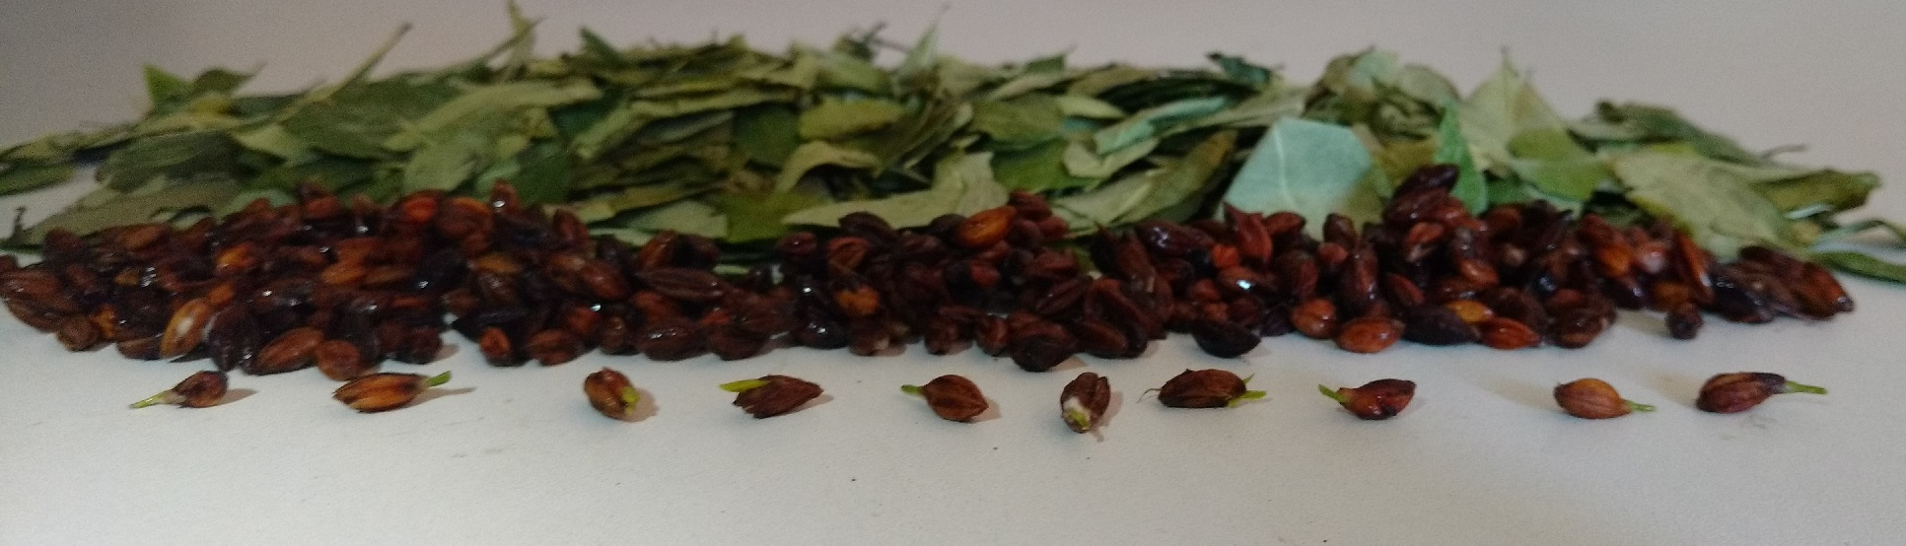

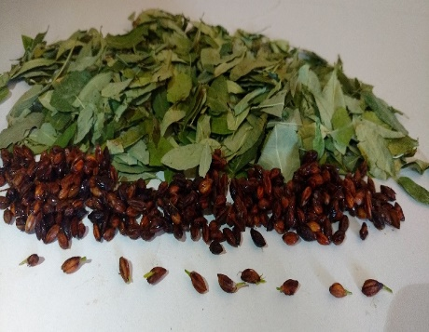
Growing and conservation of coca seeds
At an age of about 18 months, the coca plant will start flowering.
Yellow and white flowers will appear in the leaf pits. Although these flowers are both male and female, she can not fertilize herself. At least one other plant in needed for fertilization. That means that two cutlings taken from the same motherplant can not fertilize each other.
If you have two plants grown from different seeds this is not a problem; they can always fertilize each other.
To stimulate flowering, it is neccessary that you do not pick leaves off the plant. This way, she can save energy for flowering and producing seeds. Insects are needed to pollinate the flowers. After a flower is pollinated, a green berry will appear that becomes cherry red whitin 3 months. Now the seed is ready to harvest.
In the Berry is the seed. You have to remove the soft flesh of the Berry, otherwise the seed can rot or mould underground.
The best way to ensure germination of a seed is to feed the berry to a bird. The bird´s stomach digests the soft flesh of the seed while providing an acidic enough environment to inhibit bacterial and fungal attack of the seeds upon being sown into the soil.
If yoou don´t have a bird to treat the seeds, there is an alternative.
This method will extend the lifespanof your seeds. Dirty and untreated seeds have a lifespan of about 4 weeks because bacterial and fungal attack can keep them from germinating. Conserved seeds have a lifespan of about 6 months.
So, remove the soft flesh from the seeds and place them in a glass jar. Take a whole lemon (with the skin) and peel it until you have only the pulp. Mix the lemon pulp with the seeds and place it in a dark, warm (30° C or 86° F) environment.
After two days, you can rinse the seeds with water and dry them with paper towels. Now let the seeds dry for another two days. The best way to store coca seeds is to keep them in paper bag covered in spahgnum moss at 15° C (59° F) in a dark and slightly moist environment. Seeds can be stored for about 6 months; after that time the viability of the seeds rapidly decreases.

Growing coca plants from seeds
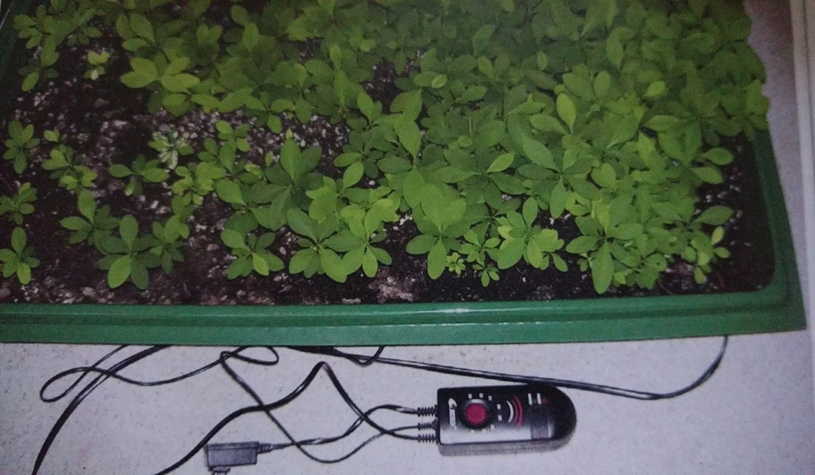

For best results, uses a propagator with soil heating.
Adjust the heat to 28°C, the optimum temperature to germinate the coca seeds. Fill the propagator with Amazonian remix soil or special seedling soil with a pH of 5 to 6, and an EC value of 0.5 millisiemens (mS), units of electrical conductance.
Spread the seeds over the soil and cover them up with 1 cm of soil
Now spray the soil with lukewarm water. Don´t make the soil too wet, otherwise the seeds will rot or mold. Place the Bonnet on the propagator; open the ventilation shaft slightly so that some air and moisture can escape.
It will take 3 to 6 weeks before the first sprouts appear. Meanwhile, spray the soil with water on a regular basic to prevent it from drying out. As long as no seeds have germinated, the propagator can stand in the dark. After the first seedling appears it is necesary to give light; however, it must not be too bright. Direct sunlight is a killer for seedlings. A T/L (tubular/ linear) tube (cool white) is ideal. Give the seedlings 18 hours of light.
Keep the T/L light tube at a distance of 30 cm. The seedlings will thrive under a T/L tube without any danger of burning.
Young coca plants need higher air humidity; keep the humidity in the propagator around 80%. For the first 3 months, it is necessary to leaves the bonnet on the propagator. Let the young plants get used to lower air humidity slowly. First, lift the Bonnet daily for a few minutes; extend this time every day. After a month, your plants will be used to lower air humidity. This is the time to transplant to a bigger pot.
Important: for the first 3 months the seedlings require no fertilizer.

Transplanting coca plants

If a seedling is about 3 month´s of age, she can be transplanted from the propagator into a plantpot.
It is best to star with a litlle pot and if the plant is well rooted it is time to go a bigger pot again
But don´t wait to long if a pot is to small it will slow down the growth and the soil is drying up to quickly.
If a pot is to large the plant can not use all the water in the pot and satys wet for to long time, wich slows down growth or can even kill a plant.
So the ratio plant / size pot is very important for optimum growth.
It is best to star with a 0,5 liter pot height 8x8x8 cm then go to
a 1 liter pot 10x10x10 cm
a 3 liter pot 20x20 cm
a 7 liter pot 30x24 cm

Eventually the plant will end up in a pot of 30-50 liters
It is preferable to take a high pot instead of a wide pot because cocaplants prefer to root Deep.
By transplanting: do compress the soil slightly to give the plant a good grip. If the soil is to loose the plant will fall ver by any wind.
Pots larger then 50 liters are difficult to handle because of their size and weight.
To protect the plants roots from damage it is important to use a rugged plastic pot of heavy quality that doesn´t deform if it is lifted
On the next page you will see a picture from the sequence of transplanting cocaplants

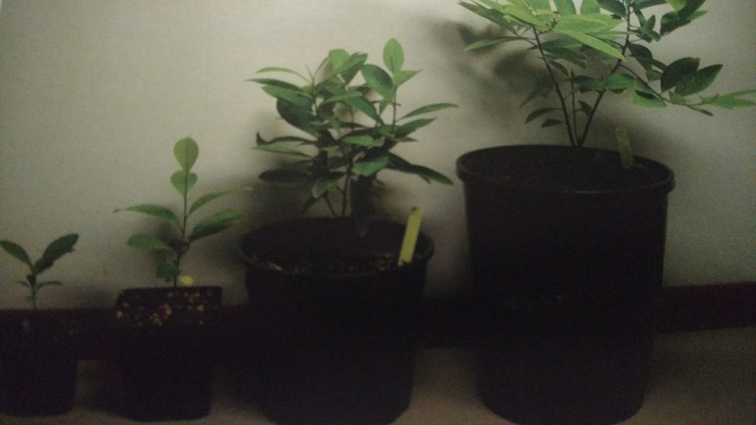

Soil for coca plants
Coca plants like well areated and mineral rich soil. On average, this soil contains clay, humus, gravel, and lava soil with a high content of iron and trace elements. The pH value is somewhere between 5.0 and 7.0, with an optimum of 5.8. The EC value is between 0.5 and 1.6 mSwith an optimum of 1.2 mS. The roots are capable of penetrating several layers of soil to get their nutrition. That is why it´s important to use a mix of these soils. Do not use commercial potting soil; this mainly consists of humus and, in most cases, your plant will die in it.
A good formula for soil is:

40% stabilised coco peat
20% akadama clay grains
20% kiriyu
20% Kanuma

Amazonian Remix is a potting soil specially designed for coca plants. The soil´s structure resembles that of the native Amazonian soil, and contains about 40% humus and 60% minerals with adjusted microorganisms. This results in a heavy but well aerated soil that gives the plant a good grip. Even in dry soil, water is quickly absorbed and the soil does not colapse. Once planted, coca plants can stay in this soil for decades. Amazonian Remix is for sale in grow shops or online at (basiliofuentes@gmail.com)

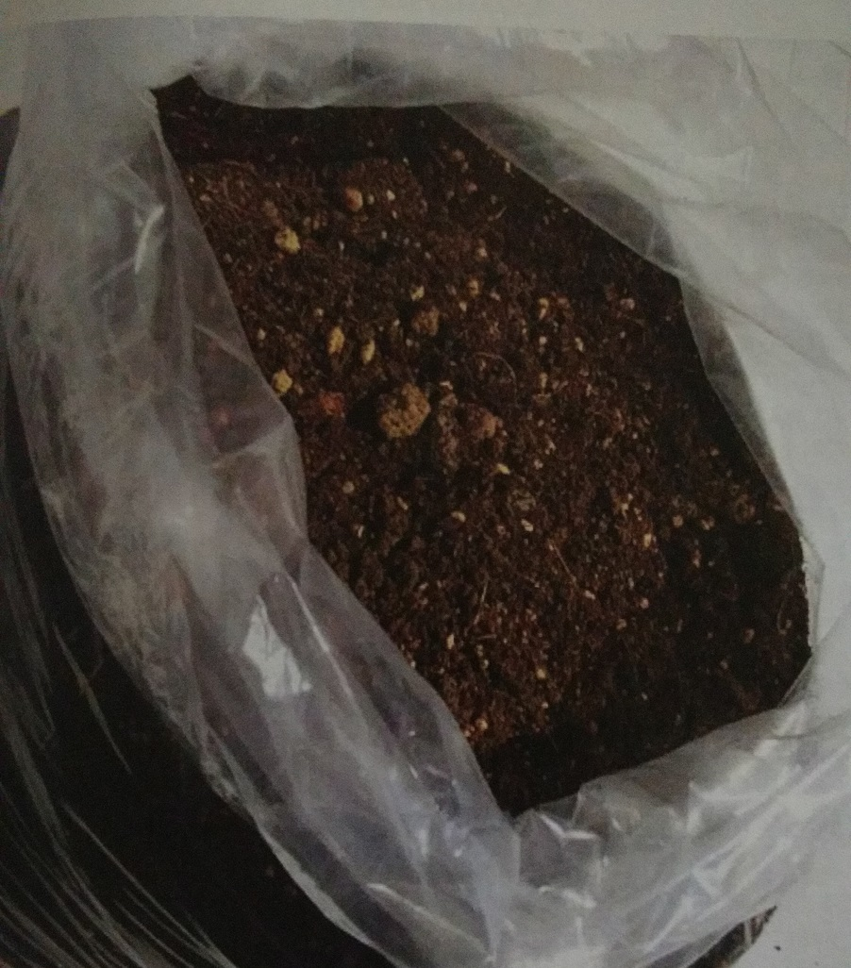

Amazonian Remix, especially designed for cocaplants

Fertilizers
Biological fertilizer:
Is based on animal or plant products. They are safe and mainly give good results. These fertilizers are easy to obtain at bonsai or garden shops. However, if you grow indoors the smell can be a disadvantage.
In full growth:
Use around 10 g of dry bio-fertilizer grains (NPK 9-3-6) per 1 liter of soil. This is sufficient for about 3 months. For garden or fruit/vegetable compost, use 30 g per 1 liter of soil. Also, add 1 g per liter of soil of magnesium sulfate (MgSO4.7H2O)
In winter, if the temperature is under 15° C (59°F) give fertilizer with NPK 3-3-6. This wy, the plant will become more resistant to cold and drought. When it warms up again, the plant will require more nitrogen. Finally, sometimes a fungus can occur on a grain of bio-fertilizer. In most cases there´s no need to worry, as the fungus is benign.
Synthetic fertilizers:
In comparison with biological fertilizers, are absorbed very quickly. Be careful, as the danger of over fertilization is increased.
Most fertilizers contain too much phosphosrous and potassium, and too few trace elements. The radio of NPK in full growth should be 3-1-2,9-3-6, or 18-6-12. If you want to experiment with fertilizers, use 1/10 the dosage; use a máximum of 0.5 mS for adult plants and 0.3 mS for young plants. If you see the fertilizer is doing well, slowly increase the dosage up to 1.2 mS for adults and 0.5 mS for younger plants.
Over-fertilized coca plants can lookvery por and one can be tempted to give even more fertilizer. Don´t get trapped. If you are in doubt, measure the EC of the soil. It should be under 1.2 mS. In case of over fertilization, rinse the soil with purified water.
If a plant looks bad, it is commonly due to over fertilization oro ver watering.
Keep in mind that plants in the shade or por light use less fertilizer.
Plants in shade or a living room need about 50% less. A shortage of trace elements often occurs in coca plants because most fertilizers don´t contain enough trace elements. In this casa, give a dosage of trace elements every 3 months. Additionally, most fertilizers do not contain enough magnesium. Once every 3 months, add 1 g magnesium sulfate per 1 liter of soil.
The soil should be rinsed with purified water every 6 months to get rid of waste and nutrients that can eventually reach toxic levels; use 2 liters of water per 1 liter of soil. Pour the water gently over the surface of the soil and let the waste water drain out of the bottom of the pot.
After rinsing, it is necessary to give fertilizer as most of the nutrients have been washed away. Give extra attention to air ventilation during this time so that the soaked soil will dry quickly.
Well fertilized coca plants can grow up to 2 cm a day!

Inca Gold liquid fertilizer is especially designed for coca plants in full growth. All the coca plants in this book are grown with Inca Gold fertilizers. This fertilizer has the exact NPK ratio sa well as calcium, magnesium, and trace elements; it´s highly suitable for growing outdorrs, in a greenhouse, or under grow lights.
Inca Gold Leaf Booster is a liquid, biological fertilizer. It contains pure amino acids for abundant shoot and leaf growth. Amino acids also increase the production of alkaloids in coca plants.

About watering
Watering
The most important issue regarding coca plant care is watering. A common cause of pale and falling leaves is over watering. Coca plants are naturally found growing on steep mountain slopes where water drains off easily, so the won´t get wet feet. The roots penetrate Deep into the soil so that in times of drought the plant will get sufficient water. A wet period of 2 months does not harm the coca plant. If it takes longer, her root system will be affected and leaves will fall off. If the situation does not improve she will die. It seems that a coca plant is more tolerant to dry soil than it is to wel soil.
Tips for watering:
The surface of the soil must be dry for 2 cm. Give 100 cc (3.38 US fl oz) of water per 1 liter of soil; a 3 liter pot will have 300 cc (10.14 US fl oz). A good auxiliary tool is a soil moisture meter. If you keep the needle in the green zone, nothing can go wrong with watering. This type of meter can be obtained at the garden center.
Larger plants are more tolerant to over watering than smaller ones because they absorb water more quickly. Push a polished wooden stick (6/8 mm in diameter) into the soil until you reach the bottom and position it there firmly. Any time you wonder if the plant needs water, just pull the stick out to see the exact moisture level in the soil.
On the left page you see picture of a young coca plant after being over watered and slightly over fertilized for one week. The top leaf curled up and the plant has stopped growing until the moisture content in the soil returns to normal.

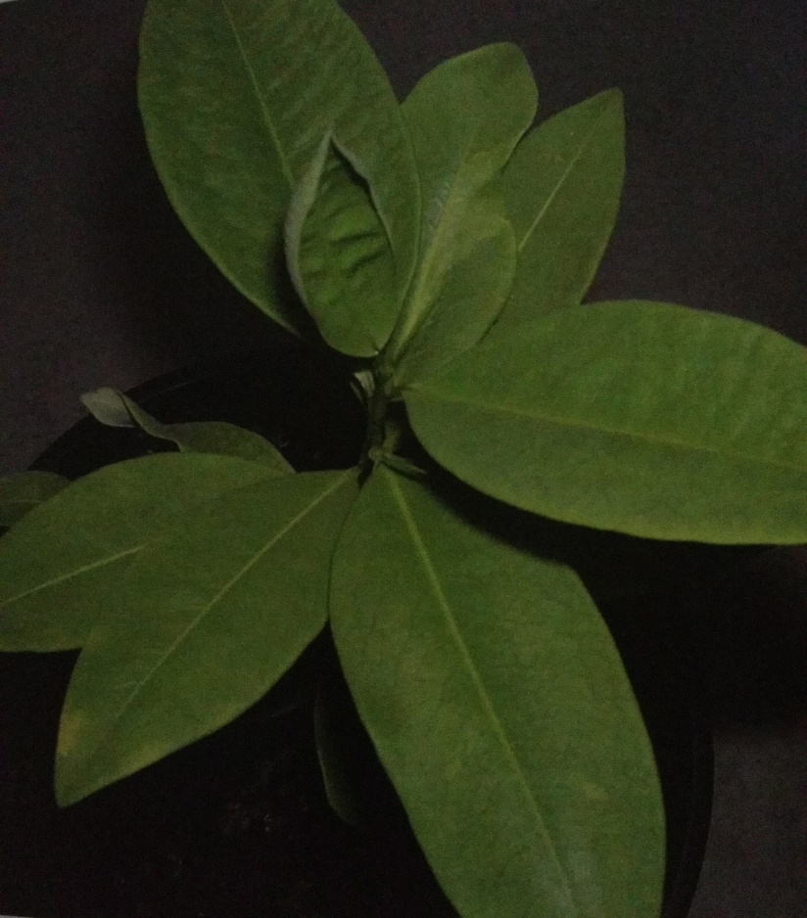

Diseases and plagues
Coca plants are resistant to many diseases and insects. On coca plats, I have never seen any common plagues like spider mites, lice, thrips, etc. Even if other plants are infected. It seems that sucking insects don´t like coca plants.
Coca plants can be susceptible for two species of fungus, Fusarium oxysporum and Phytium. They attack the rrot and vascular system of the plant. Luckily, a fungus infection is very rareo n coca plants because the are quite resistant to it. The symptoms, including falling leaves, stains, and pale leaves, are often confused with those caused by over watering. Malicious fungus can occur on badly composted plant material.
Soaked soil with poor ventilation often results in fungus infection.
If you have a heavy infection, you can use fungicides. Wait at least 2 months before harvesting the leaves after application of fungicide as it is absorber by the plant. Sometimes fungus can occur on biological fertilizers, but this fungus is usually benign and helps the plant to absorb nutrients from the soil.
The only plague I have seen is Sciaridae, a 2 mm long insect.
Their larvae feed on living root but prefer dead plant material,
Sciarid larvae resemble Little white worms about 5 to 10 mm in lenght with black heads. Sciaridae is very common in greenhouses. If you see Sciaridae, take the proper precautions; in larger numbers, they can damage your plants. The larvae nibble on the root system and infect them with fungi and bacteria.
If there is a heavy plague os Sciaridae you can use a chemical insecticide, but be aware that if youuse these you have to wait at least 2 months before harvesting leaves. Don´t use any blood based fertilizer, as thi attracts Sciaridae. In most cases, however, Sciaridae will not be a big problem.
If you grow in a greenhouse, snails can be a problem. Snails love coca leaves. They can easily be detected by traces of mucous on the coca leaves. If snails have eaten the coca leaves they can be very difficult to cath, as they are lightning fast…joke. Snails are easy to repel; lay a hand full of volcanic gravel around the stem. The rough, porous structure prevents the snails from climbing onto your plant.
You really don´t need any chemicals to keep your coca lants healthy.
If you take care of them correctly you will rarely encounter any diseases or plagues. It is wiser to create the right growing conditions for your plants than to star chemical warfare with them; a disease is most directly related to bad growing conditions. Only use chemical fungicides or insecticides if there are not alternatives.
Also, it´s important to be aware of the waiting period necessary for safe comsuption. Finally, do not use the so called “systemic”
Insecticides or fungicides. They enter the vascular system of the plant and stay there for a much longer time; they are poisonous to humans and animals.

Growing outside
Coffe and tea plants often grow well alongside coca plants; in a mountainous región in the tropics, sufficient rainfall and milder temperaturas allow the plants to retain their delicate aroma.
The climate at this altitude is more subtropical, like that of the Mediterranean or the southern United States; if you live in a similarly frost-free área it is very easy to grow coca plants outdoors.
You only have to dig a hole in the ground and fill it up with garden compost. Plant your coca bush and water it twice a week if there is insufficient rainfll. Place fencing around the coca plants to protect them from rabbits, goats, and deer. In the northern hemisphere the summer is the only posible time to grow coca outside, but conditions are nearly ideal at that time.
Moderate temperaturas and 18 hours of daylight allow the coca plants to thrive, and harvest of good quality is possible.
June through August is the time to place your coca plant in a sunny spot in the garden in the vicinity of a brick wall. The wall serves to absorb heat during the day and radiate it at night, warming the plant.
Place a sunscreen above the plants that are first coming into contact with sunlight. Plants that are not used to bright sunlight will burn if they are over exposed to it. They have to get used to the light gradually.
Be aware that a coca plant can drink three times as mucho on a hot day
Finally, if temperatures are under 10°C (50°F) it is safer to place them inside, despite their tolerance to low temperatures.

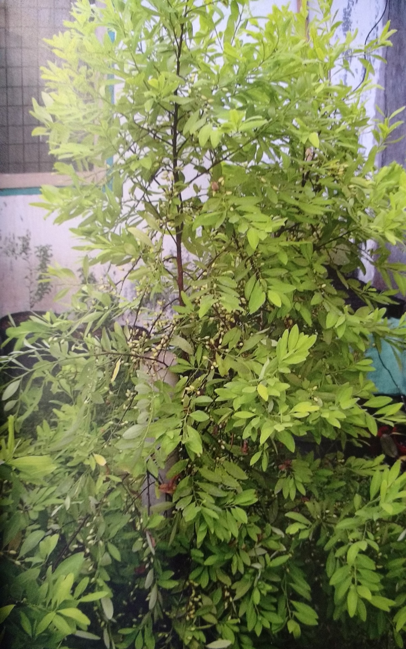
Growing in greenhouse
In the northen hemisphere, coca plants grow well in green houses all year round. The longer photoperiod in summer is no problem to coca plants. They will only grow faster and perhaps flower, get pollinated, and produce seeds. On very hot days, it is necessary to cover the greenhouse with a (30%) light blocking sunscreen. This will prevent the temperatures above 35° C (95°F). Young plants up to 1.5 years always need susncreen protection. Sometimes even with a sunscreen the temperatures can rise to 50°C (122°F) and air humidity can drop to 25%. It´s amazing that, with sufficient water, the adult plants keep their heads up under these conditions. But younger plants will show signs of stress under the same conditions. Spray the younger plants with cool water and they will recover.
The shorter photoperiod in the winter is not a problem. The coca plant will only grow more slowly than she does in the summertime. It is important to heat the greenhouse if the night temperature drops below 10° C (50° F). Adjust the heating to 22° C (71.6°F). An electrical heater of 2 kilowatts is sufficient for 10 mt2. Even a petroleum or gas burner can be used for heating; the C02 (greenhouse gas) benefits the growth of the coca plants. You can save a lot of energy by insulating the greenhouse with a light permeable insulating screen. Air ventilation is important in the winter time as well. If a petroleum or gas heater is used, attention to ventilation is especially necessary.

Growing lights
It is important to be aware of two things; light intensity and photo period. Light intensity is measured in lumens. Photo period is mesaured in hours per day.
Young plants don´t need bright light. They tolerate only 1 hour of direct sunlight; if they are over exposed to britght light the leaves turn yellow or burn. Young coca plants have a tolerance of 24 hours of (T/L) 33 Whats a day. If the root system og the plant is well developed the need for light increases; in this case, more light means better growth. However, over fertilized plants have a lower tolerance to bright light.
Adjust the light intensity to the fit the needs of the plant.
To accustom a coca plant to bright light, it is necessary to increase the photoperiod and light intensity gradually. A coca plant 12 months of age has a tolerance of 14 hours of sunlight and is thus finished with light training; in their natural enviroment, coca plants have a photopoeriod of 10 to 14 hours of daylight. They thrive very well under artificial grow lights with an intensity of 20,000 lumens per mt2.
Mature plants can even handle 40,000 lm per m2.

Suitable lights for coca plants:
. Mercury Iodine (400 watts) for 1m x 2m (3.3ft x 6.5ft) surface; 75 cm from plant
. Sylvania Cool White (two 58 watts) for 1 m x 0.5m (3.3ft x 1.6ft) surface; 50 cm from plant
.T/L (tubular /linear) tuve Cool White (five 33 watts) for 1m x 0.5m (3.3 ft x 1.6ft) surface; 30 cm for coca plant

Coca growing in living room
The coca plant is very easy to grow in a living room. A conservatory is the best place for coca plants but a bright, sunny place near a large window is suitable and the plants will grow reasonably well.
Give the plant as much light as possible.
Coca plants grow three times faster than ficus benjamina under the same conditions. Be cautious of high temperatures. If it is sunny and the curtains are clossed, the temperature behind the window can rise to intolerant levels. Plants located on the window sill will be affected; take your plants away from the window if you close the curtains.
It is preferable to keep a distance of 1m from central heaters.
A coca plant smells slightly like green tea, so one doesn´t have problems with heavy odors like those produced by cannabis plants.
If you want some extra growth in the winter, auxiliary growing lights are an option. They will give supplementary lights are an option. They will give supplementary light in darker periods.
The sylvania 2 x 58 watts is suitable for growing in a living room or bedroom. There is even a luxury design called “Ladybird” (1 x 58 watts). It radiates light straight down so it will not disturb you if you watch televisión. These lights give a lot of light but only a little hat, so extra ventilation is not necesary. Consequently, if you use large quantities of these lights in one room then extra ventilation and air circulation is needed.

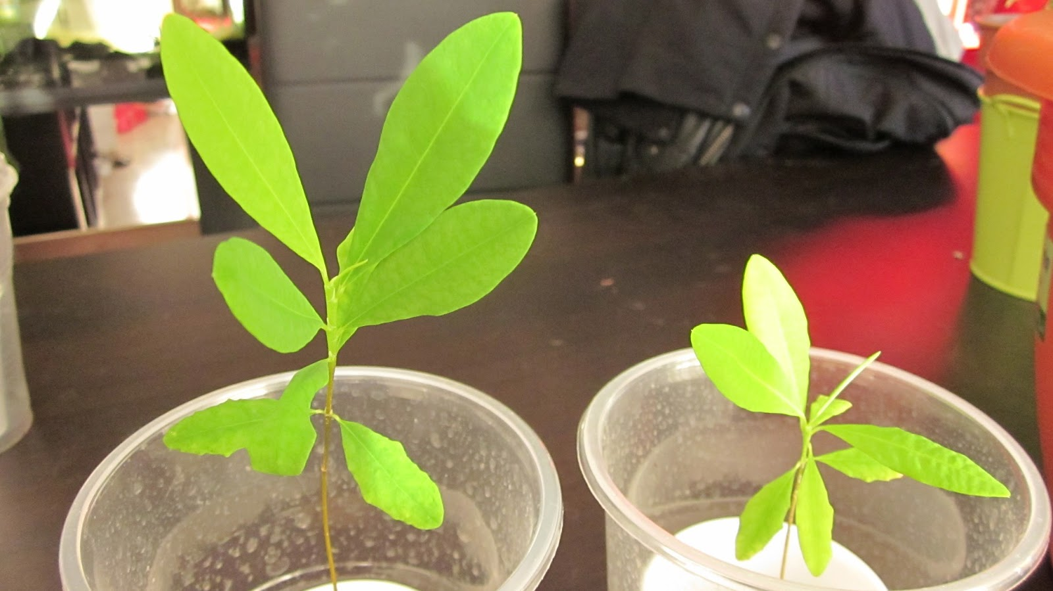

Growing under 400 watt. Mercury – Iodine
For those who have large appetites for coca leaves, growing plants under a 400 watt mercury iodine light is a good option. Coca plants will grow faster than they would in their natural habitad because the photoperiod can be extended to 18 hours a day. Now you can play god and create the optimum conditions all year around.
Mercury-iodine lights produce bright white light similar to sunlight.
Furthermore, you must build a special room with proper air ventilation and circulation so that it´s possible to control temperature and air humidity. You can find all the required materials for this at grow shops. An air deodorizer is unnecesary, as the plants do not spread any odor.
For plants 12 months old and younger, use a 400 watts light on a surface of 1m x 2m (3.3ft x 6.5ft). Keep the light 1m above the plants.
For plants older than 12 months, use a 400 watt light on a surface of 1m x 1m. Keep the light a mínimum of 50cm (1.6ft) above the plants.
Air humidity should be around 70% for younger plants and 50% for mature plants. For máximum growth, the temperature must be between 20° C and 30° C (68°F and 86°F).
Take care that is sufficient air circulation, but don´t aim the ventilator directly on to the plants, as heavy winds can damage leaves.
It is preferable to aim the ventilator toward the ceiling. Spray the plants once a week with distilled water or rainwater to keep the pores of the leavesopen. The plants will love it, and it will increase growth and health. Young coca plants grow slowly at about 2cm per month. Under 400W light, mature coca plants can grow up to 2 cm per day!

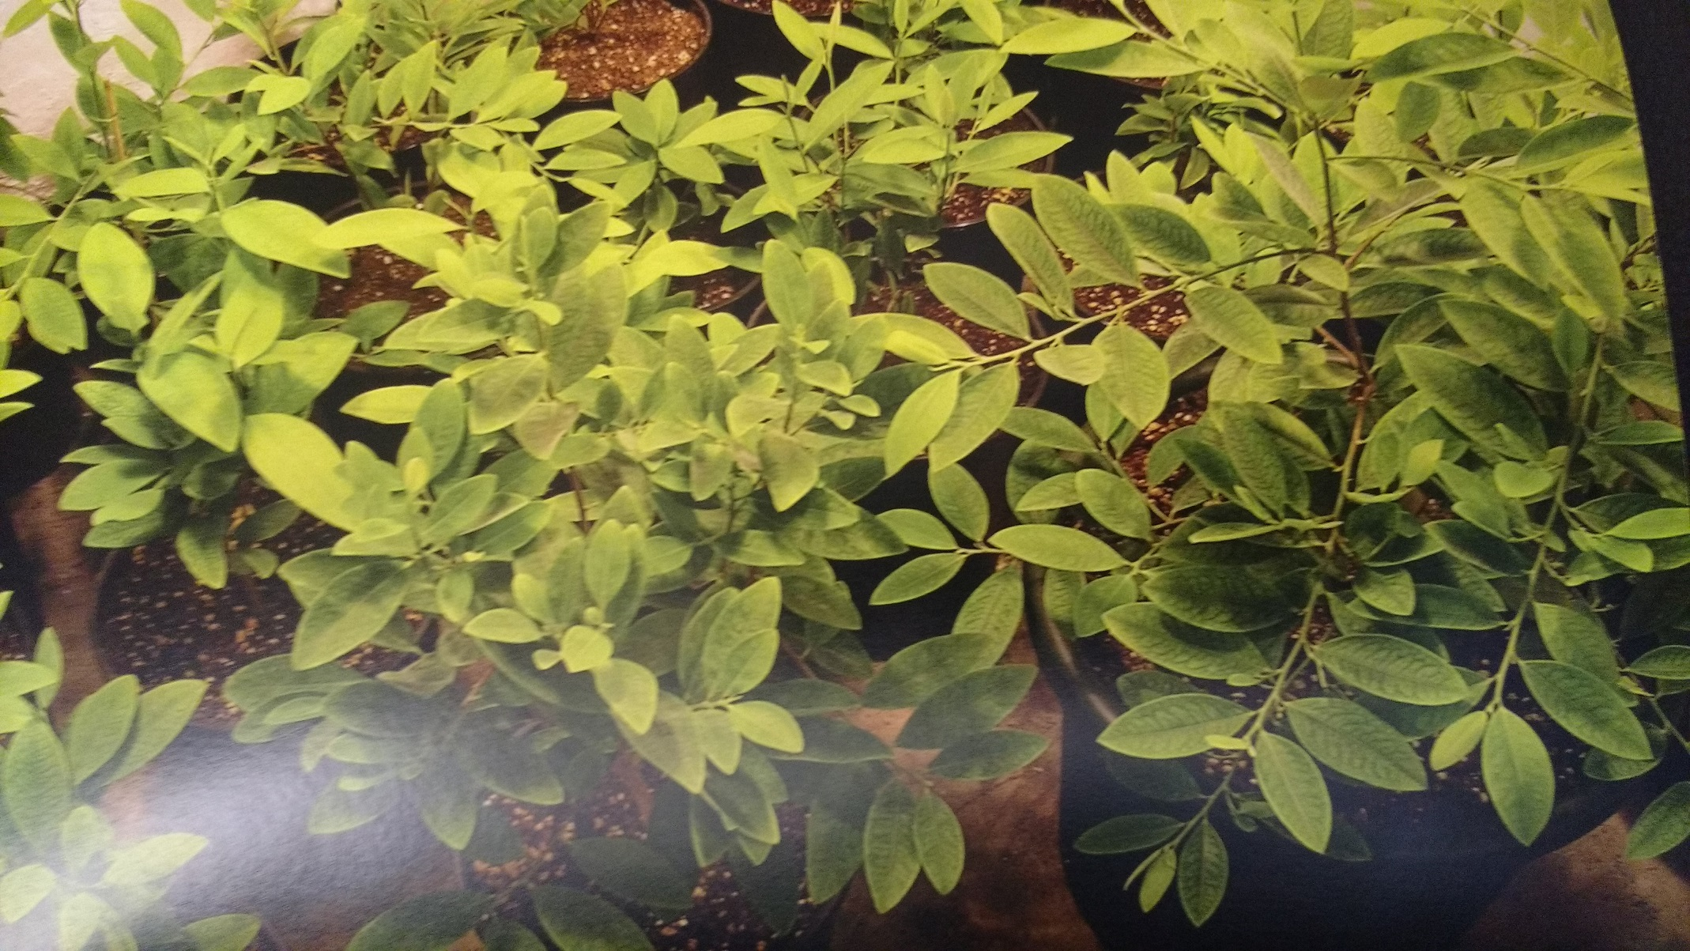

Harvest and drying of coca leafs
When a coca lea fis about three months old, it is at its peak regarding alkaloid content. The leaves get lighter in color than the younger leaves. This is the time tto harvest. You can pick more leaves from a larger plant than you can from a younger one. Picking leaves does stimulate new leaf growth but be careful with younger plants. If you pick too much you´ll slow down growth. Don´t harvest more than 25% of the leaves.
For every leaf you pick a new branch will grow out which produces more leaves. After a while, the plants become very bushy and you must prune them. You can use the leaves from these branches as well. Young leaves contain about 30% less alkaloids.
For máximum yield, you have to pick the mature leaves every day.
This is more work but you will have quality, fresh leaves dor daily use.
And if you don´t want to spend that much time harvesting the leaves, it is possible to trim the coca plants once every three months.
The average quality will be a little lower, but this is the most common way to harvest coca leaves.
Coca leaves can be eaten fresh; they are delicious. Coca leaves are dried for storage and distribution purposes. Well-dried coca leaves can be stored for for over a year. It is simple to dry coca leaves, but it must be done precisely in order to maintain the optimum taste and prevent them from rotting or molding.
Spread out the leaves under the sun or a powerful light. Turno ver the pile of leaves every 2 hours until the leaves have lost about 50% of their weight. This takes about 12 hours.
Store the leaves out of the sun in a dry room for another day. Now the coca leaves are ready to be stored in a plastic bag.
Note: The leaves that are stored moist are going to mold
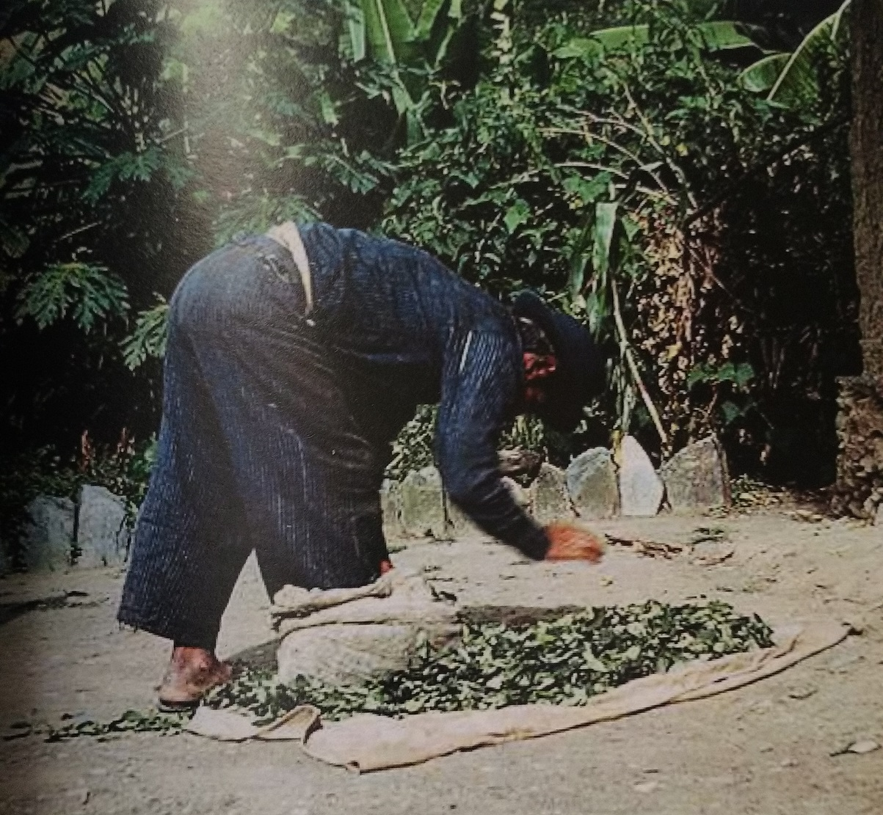

Rum & Coca leafs
This is a very popular drink in the higher Andes. It is a mix of rum and coca leaves. On a cold day it warms you up quickly.
Fill up a 1 liter bottle of rum with 20 grams of dry leaves or 40 grams of fresh leaves. Store it in a dark place for at least one month. If it is stored longer, the quality will be even better. The alkaoids, taste and aroma of the coca leaves will be absorbed by the alcohol and leave the drink aromatic and britgh green in color.
Even experienced whiskey or cognac drinkers praise the aroma and rich taste of this drink. The taste and effect of this drink are very pleasurable. After a few sips you feel simultaneously relaxed and energized, and you become talkative. I have had many good conversations with people while drinking this, and many hours have flown by in sociable coziness; a very remarkable drink.
Another remarkable quality of this drink is that it abolishes stress related pain such as headaches and lower back, shoulder, and neck pains. It´s actually an enjoyable medicine!
If you don´t like the taste of rum, vodka or Dutch Genever gin can be used. I personally prefer to mix the coca leaves with Swedish Absolut Vodka. I don´t know if they are happy with this free advertisement, but to me it gives the best results in taste and the transparent, bottle looks very decorative when filled with coca leaves.
Fresh leaves are easier to put into the bottle than dry leaves, and they give a slightly different but equally enjoyable taste. It is not possible to put more than 60 grams of fresh leaves into a bottle; the water in the leaves take down the alcohol content and they can rot. With dry leaves, however, there is no limit. If the bottle is empty, it can be refilled and stored a second time. It´s two times the fun with one portion of leaves!

Coca Tea
The taste of coca tea resembles the taste of Chinese green tea, but is less bitte. Coca tea can be flavored with sugar or honey, but tastes mildly sweet on its own.
Green tea is mainly used because it contains flavanoids that benefit the health and eliminate free radicals in the body. Coca leaves contain as many flavanoids as green tea and have a multitude of other health benefits as well. The stimulating effect of one cup of coca tea is comparable to one cup of coffee, yet friendlier to your stomach. One can drink the tea all day long without side effects such as nausea; in fact, it relieves nausea. By drinking coca tea throughout the day; you maintain an energetic vibrance and a more focused concentration for the task at hand. It doesn´t stain your teeth, either! A disadvantage of coca tea is that you have to use a relatively high amount of leaves in comparison to chewing leaves or dipping them in alcohol. But by growing your own bush, you will have enough leaves to drink coca tea all day long.
To make coca tea:
Fill one cup with about 10 coca leaves.
Boil water and let it cool to 90°C (194°F). This is important, as otherwise the tea can taste like vegetable soup. Coca leaves consist of many delicate flavors that are not tolerant to temperatures higher than 90°C pour the water into the cup and let it steep 5 minutes before drinking it.
Due to the low air pressure at Andean heights the water boils at 89°C; boiling water is never too hot to make coca tea here.
To make a coca soft drink:
Boil 1 liter of water and let it cool down to 90°C Use twice the amount of leaves as for coca tea. Add 0.25 gram of sodium bicarbonate and 15 grams of honey. Store it over night in the refrigerator. A very refreshing and energizing drink, now you have your own Coca tea-ola.

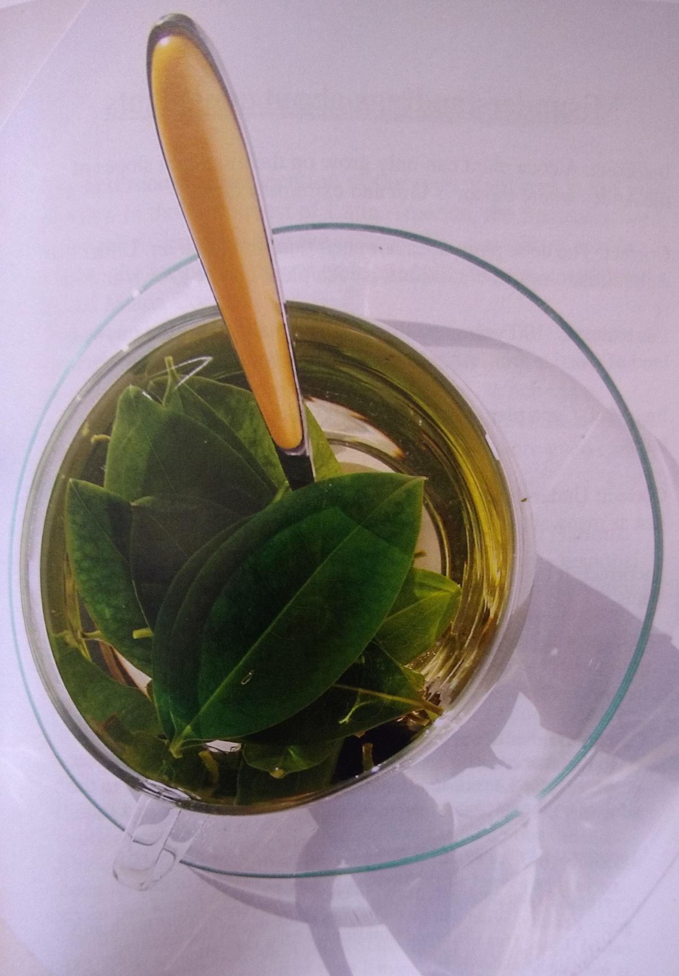

Misunderstandings about coca plants
Incorrect: A coca plant can only gro won the mountain slopes of the Andes where the air is thin and extremely clean.
Correct: The coca plant does not need thin mountain air. Under the right climatological conditions, a coca plant can be grown anywhere. For example, 100 years ago there was small plantation on the island of Corsica from Angelo Mariani, the inventor pf coca wine.
Incorrect: Coca plants grown at sea level don´t produce any alkaloids
Correct: Under the right growing conditions, the plants produce just as many alkaloids as when grown at higher altitudes.
Incorrect: It takes three years before a coca plant produces alkaloids.
Correct: Even seedlings produce alkaloids.
Incorrect: Chewing coca leaves is bad for your health.
Correct: Studies of various universities and the United Nations have shown that coca leaves are not bad for your health. Refer to the chapter “Coca leaves and health”. You can read more about this subject on the internet.
Incorrect: Chewing coca is bad for your teeth.
Correct: To the contrary; chewing coca leaves keeps your teeth and gums healthy. What can be damaging is the use of the addtive called llipta. This is burned limestone with a very alkaline pH that is used as an accelerator

The persecution of coca plants
The first recorded persecution of the coca plant was in the 16th century. In their conquest of latin America, the Spaniards were fanatically Christianizing the natives. The coca plant was sacred to the Incas and they worshipped the plant as a goddess called Mama Coca.
This was a threat in the eyes of the Spaniards. They destroyed nearly all the coca plants in the Incan empire and those who possessed the plant were severely punished. When the economy nearly collapsed because of malnutrition of the population, the persecution was withdrawn and taxes were even charged on coca leaves.
In 1961, a new prohibition was started. The United Nations proclaimed that the consumption of coca leaves was responsible for poverty and poor health. In 1997 a later United Nations investigation claimed that the use of coca leaves was not dangerous to your health. Yet growing coca plants remains prohibited due to the illegal production of cocaine, despite the ongoing permitted cultivation of coca plants for pharmaceutical use.
In this treaty of the United Nations, a number of countries have a quota of coca leaves or cocaine that they are allowed to produce or import. By this treaty, the price of pharmaceutical (legal) cocaine is held at an exorbitant amount. Legal pharmaceutical cocaine is even more expensive than illegal cocaine.
Since 1914, the Coca-Cola Company has used de-cocainized coca leaves to flavor their beverage. It remains the only Company in the world that can import as many coca leaves as it needs for its production of Coca-Cola, some 2500 tons of coca leaves per year.
By this construction, the United States is not restricted by any limits on the importation of coca leaves.
All these leaves are de-cocainized by the Stephan Chemical Company.
Where isa ll the cocaine going? It is sold to the pharmaceutical companies. Consequently, the United States is a market leader in pharmaceutical cocaine and cocaine related products such as novocaine and procaine. Every year, billions of dollars are made by the trade of coca leaves and it´s products. This market is important enough to the American government that they proclaim war against the illegal growing of coca plants. All plantations that don´t deliver their coca leaves to the Americans and the pharmaceutical industry will be destroyed. By doing this, they dominate the world market for coca leaves.
The drug czars by coca leaves meant for the rural population that depends on them for nutrition. They are, therefore, deprived of an important source of food. The war against coca is very damaging to humans and the animal populations.
One can truly say that the warfare against drugs causes more victims than the drug itself.
The coca plant has been called a “demonic plant” by the American government, despite making plenty of money with it legally. What started in 1961 as a way to protect the American pharmaceutical industry has become a ferocious war. Is it not ironic that the country wich makes the most money on legal cocaine? Furthermore, their fundamentalist attitude towards drugs only makes problems worse.
This chapter is a survey out of the book “Coca the Legend” of Dr. Jorge Hurtado Gumicio
Jorge is a psychiatrist and real promotor of the coca plant, he treats cocaine addicts with coca leafs and is successfull within his therapy, and worldwide he try´s to bring this under attention.
He is the director of the coca museum in La Paz- Bolivia, and also produced the documentary film “Hierba Mala”
People whom are interested in the work of Jorge can contact him on www.cocamuseum.com
United Nations Quota Treaty E/INCB/1983/5
Following countries are permitted to produce or import:
Australia 4 Kg coca leaves
Austria 4 Kg
Belgium 28 Kg
Canada 55 Kg
Germany 149 Kg
Finland 27 Kg
France 28 Kg
United Kingdom 3 Kg
Hungary 2 Kg
Hong Kong 7 Kg
India 13 Kg
Ireland 2 Kg
Israel 1 Kg
Japan 50 Kg
Malaisia 6 Kg
Netherlands 22 Kg
New Zealand 17 Kg
Poland 13 Kg
Korea 1 Kg
Rumania 25 Kg
Russia 100 Kg
Singapore 3 Kg
Spain 4 Kg
Sweden 1 Kg
Switserland 32 Kg
Thailand 1 Kg
Turkey 52 Kg
United Sates 530 Kg
Italy 10 Kg
As you can see, the United States already has the highest quota of all the countries on the list. On top of that, the Coca-Cola Company is permitted to import as many coca leaves as needed for the production of Coca Cola (some 2500 tons in 2013).

